Trent Lakes
2022
Waste Management Report

The Resource Productivity and Recovery Authority (formerly WDO) Datacall is a waste management report done yearly by County of Peterborough Waste Management to ensure funding of the Blue Box Program. Due to the upcoming transition of the Blue Box Program to Producer Responsibility on January 1, 2024, the County was not required to complete a Datacall for 2022. The data collected in 2023 will be the last year that diversion rates will be available.

Figure 1 below shows the County diversion rate at 54% with township diversion rates ranging from 43% to 61% in 2022.

Figure 1: County and Township Diversion Rates 2022

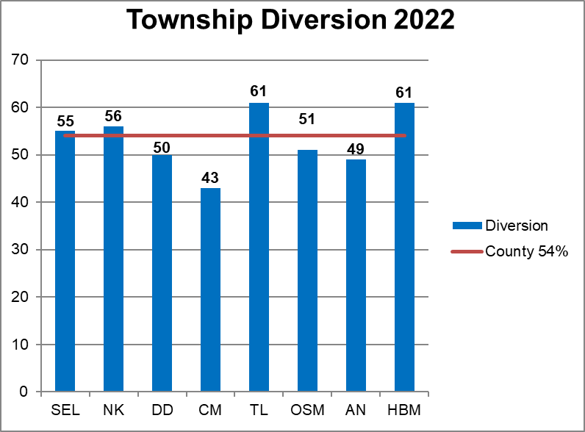

Waste in the County is composed of garbage and various recyclable or divertible commodities such as blue box materials, scrap metal, construction materials, hazardous waste and organic waste. Figure 2 below shows the composition of waste by township. The ‘other’ category includes scrap metal, construction waste, hazardous waste and electronics, textiles and reuse.

Figure 2: Composition of Waste by Township in 2022

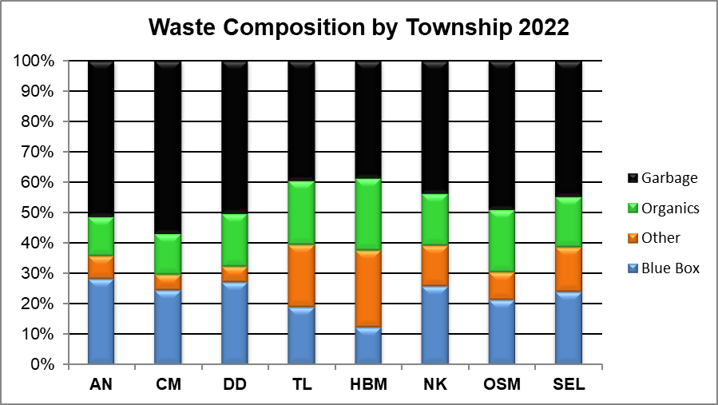
*Organics includes backyard composting, leaf and yard and organics;
Other includes: C&D, scrap metal, reuse, MHSW/WEEE, tires, mattresses, hard plastics

Figure 3 below compares Trent Lakes and County statistics from 2021 and 2022. The residential households are all households including seasonal households as derived from MPAC and the County planning department.

Figure 3: County and Trent Lakes Comparison
Year | Municipality | Households* | Garbage Per hhld (kg/yr) | Blue Box Recycling Per hhld (kg/yr) | Overall Diversion Rate (%)
2021 | Trent Lakes | 7,005 | 185 | 92 | 56
2021 | County | 36,977 | 323 | 153 | 51
2022 | Trent Lakes | 7,031 | 175 | 77 | 61
2022 | County | 37,247 | 311 | 146 | 54

Waste composition will be a bit different every year as residents disposal habits change or events happen in their lives. The waste composition for Trent Lakes is shown below in Figure 4 and compares data from 2019 to 2022.

Figure 4: Changes in Trent Lakes Waste Composition 2019 to 2022

Material Type | 2019 Tonnes | 2020 Tonnes | 2021 Tonnes | 2022 Tonnes
Curbside Blue Box (campground program) | 35.64 | 27.88 | 31.27 | 29.20
Depot Paper | 280.25 | 282.30 | 303.91 | 282.96
Depot Containers | 317.40 | 301.55 | 311.82 | 282.04
Tires | 7.44 | 19.13 | 10.24 | 8.22
Scrap Metal | 116.48 | 153.84 | 179.10 | 179.28
Construction | 325.14 | 246.91 | 292.86 | 281.49
Organics | 508.04 | 453.13 | 486.26 | 665.31
Re-Use | 66.20 | 56.00 | 6.92 | 108.32
MHSW/WEEE | 86.70 | 46.81 | 61.59 | 67.51
Depot Garbage | 1,068.96 | 1,224.02 | 1,299.31 | 1,231.92
Overall Diversion Rate | 61.99% | 56.46% | 56.45% | 60.72%

Figure 5 below shows the 2022 composition of waste for Trent Lakes by percentage.

Figure 5: Composition of Waste in Trent Lakes in 2022

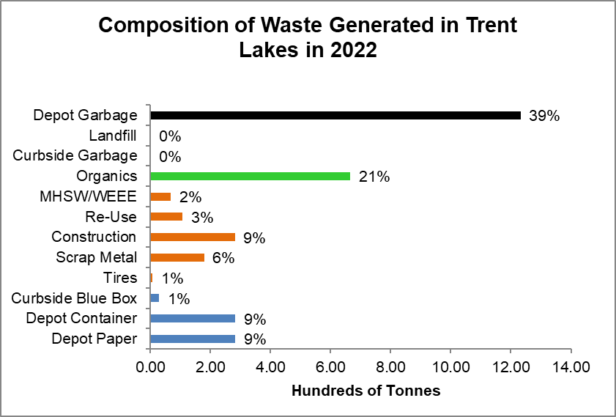

The County has conducted many waste audits over the years. The future goals for waste composition shown in Figure 6 is based on this data and the assumption of diversion programs being available.
Figure 6: Future Goals for Waste Composition

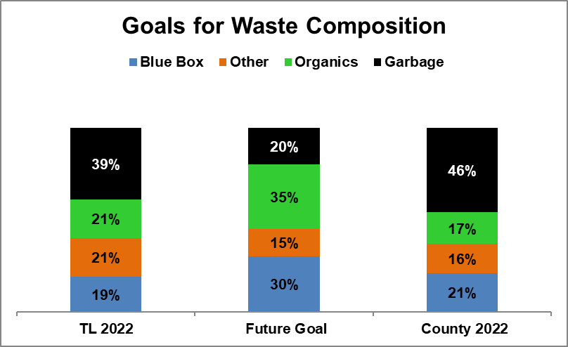

Waste Management Terminology

Acronyms:
BB = Blue Box
BYC = Backyard Composting
C&D = Construction & Demolition
MHSW = Municipal Hazardous or Special Waste
WEEE = Waste Electronics and Electrical Equipment
HHLD = Household
GAP = Generally Accepted Principles (Datacall generated number)

Where the numbers come from:
- City of Peterborough scale reports (Landfill and Recycling Facility)
- RPRA Datacall – calculations and other resources
- Township Staff - estimates and/or scale records
- Household Data – Municipal Property Assessment Corporation (MPAC) and County Planning Department

