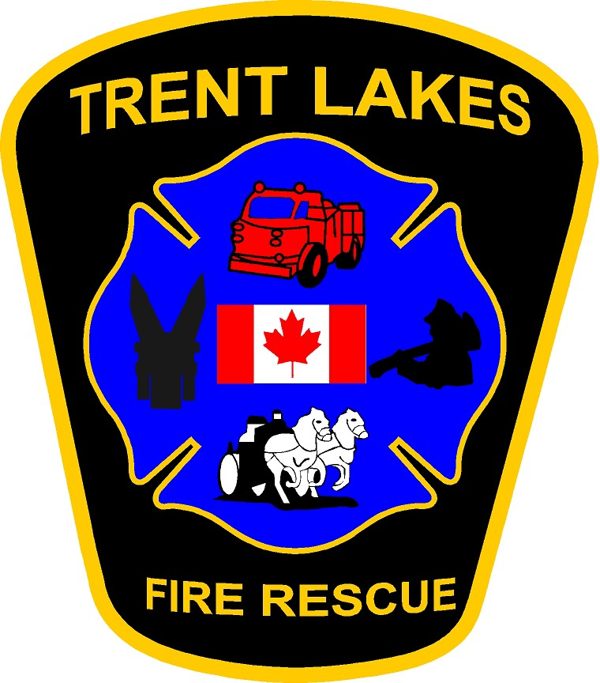

Trent Lakes Fire Rescue

**2025 Firefighter Recruitment**

**Guide**

**760 County Rd 36 Trent Lakes ON K0M 1A0**

**705-738-3800 ext 230** [**sjackett@trentlakes.ca**](mailto:fire@trentlakes.ca)

# TABLE OF CONTENTS

Letter from Trent Lakes Fire Department 3

Job Description 4

Recruitment Program 8

Purpose 8

Program Steps 8

Step One – Application Submission 8

Step Two – Information Session 8

Step Three – Physical and Written Assessment 8

Step Four – Final Review 8

Part A – Selection & Acceptance 9

Part B - Documentation to be submitted after conditional offer made 9

Part C –Offer of Employment 10

General Information 11

Thank you for your interest in Trent Lakes Fire Rescue. This information package contains all the relevant information associated with Trent Lakes Fire Rescue Volunteer Firefighters including the steps involved in the recruitment process for this position.

Trent Lakes Fire Rescue is what is commonly referred to as a “composite” fire department. This means that our firefighting staff is comprised of both full-time (Fire Chief, Deputy Fire Chief, Fire Prevention Inspector, Training Coordinator, Fire Administrator) and Volunteer Firefighters.

The department provides 24-hour emergency response to the community in the following areas;

Medical response

Fire suppression Technical Rescue

Hazardous material operations level response

Technician level ice and water rescue

Remote locations (boat/atv)

Vehicle extrication

Public hazards

If you are selected to become a member of Trent Lakes Fire Rescue, you will be expected to participate in the department’s Public Fire Safety Education Program and various other public relations activities. As a condition of employment, you will also be expected to participate in the department’s Comprehensive Training Program. You are expected to attend a minimum of 50% of paged calls as well as attend a minimum of 60% of scheduled training sessions.

Although the position is referred to as “Volunteer Firefighter”, you will receive remuneration for your service with Trent Lakes Fire Rescue as outlined in our Memorandum of Understanding.

The job requires commitment, devotion, compassion and above all, a desire to serve your community. With this being said, the rewards of being a volunteer firefighter far outweigh the demands of the position.

Please review this package in its entirety and should you have any questions regarding this position, or the recruitment process, we would be more than happy to assist you.

Steve Brockbank,

Fire Chief

TRENT LAKES FIRE RESCUE JOB DESCRIPTION

|  |  |
| --- | --- |
| **POSITION**: Volunteer Firefighter | |
| **REPORTS TO:** Captains of the Department | **DATE:** January 2024 |
| **THIS JOB DESCRIPTION IS**:  NEW  EXISTING  REVISED RESCINDED | |

# JOB SUMMARY:

A Trent Lakes firefighter is required to have the desire to help people and give back to the community by responding with courage, dedication, compassion and have a willingness to learn new skills and face new challenges.

The firefighter serves the community by responding to a wide variety of situations, ranging from emergencies that immediately threaten life or property to routine citizen requests for information or assistance. They follow the policies and procedures of the Trent Lakes Fire Rescue and work within all Standard Operational Guidelines/ Procedures, regulatory acts, and health and safety guidelines. The firefighter works under the supervision of a fire officer(s) and is expected to perform effectively as part of a highly trained and professional team.

Firefighters are required to respond to calls for emergency assistance including but not limited to fires, medical emergencies, motor vehicle accidents, water/ice rescue, and hazardous material incidents. In addition to emergency response and training, firefighters participate in fire prevention, public education, community events, and fundraising functions.

The firefighter must be committed to respond to calls day or night, weekends, and holidays, with the unforeseen potential for extended durations above and beyond.

# DUTIES AND RESPONSIBILITIES:

* Respond to and actively participate in the delivery of all fire protection, education, and prevention services, through the effective assignment of equipment and apparatus.
* Responsible for the care, maintenance, and cleaning of all fire assets including but not limited to apparatus, equipment, and station(s).
* Advise the Captain(s) of any required repairs and maintenance items pertaining to apparatus, equipment, and stations.
* Responsible for all firefighting duties necessary to save life, protect property, and preserve the environment including fire suppression.
* Responsible for the continuity of information as per the organizational chart.
* Interprets, clarifies, understands, and carries out firefighters’ duties in a timely and efficient manner.
* Required to complete and submit all reports and other documents in a timely matter for office recording.
* Work in compliance with the Occupational Health and Safety Act, Section 21 Guidance Notes, Fire Marshal’s Guidelines, Highway Traffic Act, WHMIS, municipal by-laws, applicable legislation, regulations, statutes, departmental policies/procedures/practices, operational guidelines, and perform safe work practices.
* Attend training and meetings as scheduled and/or requested.
* Assist in determining the cause of fires in conjunction with officers.
* Participating in departmental training programs (NFPA programs and other assigned courses) to remain current with both new and existing legislation, ensuring that personal development is valued and undertaken, and that departmental fire safety standards are met, and professional competence is maintained.
* Any or all other duties as assigned.

# HEALTH AND SAFETY:

All Employees are responsible to be aware of, understand, and follow the Occupational Health and Safety Act, by taking reasonable precautions to protect themselves and fellow workers from health hazards and unsafe situations. Employees are required to follow any Health and Safety policies and procedures established by the Municipality.

# SUPERVISION:

This position does not supervise others.

# CONTACTS:

**Internal:** With the Captain, District Chief, Deputy Fire Chief, Fire Chief, and co- workers for the purpose of obtaining and sharing information to complete related tasks.

**External:** With various Federal/Provincial/Municipal agencies and organizations to provide and obtain information. With the public to provide accurate information, ensuring polite and tactful relations.

# WORKING CONDITIONS:

* Exposure to physical and fatal hazards including but not limited to fire and smoke, traffic accidents, hazardous materials, unsafe ice and water conditions, electrical shock, heights, and having contact with persons experiencing adverse trauma.
* Expected to work in all types of weather conditions and challenging environments. Incumbents may be required to enter hazardous atmospheres and environments from time to time as well as extreme and adverse outdoor weather conditions including unfavorable conditions such as noise, dirt, odors, physical hazards, and/or health and safety risks.
* Visual and mental concentration with respect to life safety is imperative.
* Ability to be on call days, nights, weekends, holidays with the unforeseen potential for extended durations above and beyond. Must be willing to carry a pager/notification device.

# JOB KNOWLEDGE

* Mental alertness, mechanical aptitude, ability to get along with others, willingness to perform tasks as assigned, conscientious and dependable, good physical condition, holder of a valid Class “D” license complete with “Z” endorsement or able to acquire license within two (2) years of joining the department or within one (1) year of being promoted to the rank of Firefighter or as scheduling will allow and be approved by the Fire Chief.
* Working knowledge of modern firefighting and fire prevention methods, rescue, first aid procedures, rules, and equipment.
* Knowledge of the Fire Protection and Prevention Act, 1997; and Fire Code O. Reg. 213/07.
* Knowledge and skill in safe operation of all types of fire and emergency vehicles, equipment, and safety and protective devices.
* Thorough knowledge of the municipality and surrounding areas and types of infrastructure within municipality.
* Ability to quickly assess and strategically take control and respond to emergency situations; to deal effectively and courteously in all aspects of the position; to demonstrate tact and discretion in handling matters of a confidential or politically sensitive nature and to maintain confidentiality.
* Maintains a sense of public service, strong interpersonal and public relations skills.
* Must be aware of organizational goals, policies, best practices, safety issues, and all department operations and functions.
* Preferred qualifications would include NFPA 1001 Firefighter Level 1 and 2, NFPA 472/1072 core operations, or equivalents. If candidate doesn’t currently possess NFPA 1001 Firefighter Level 1 and 2, NFPA 472/1072 core operations level, the candidate will be required to successfully obtain within two (2) years or as scheduling will allow and be approved by the Director of Emergency Services/Fire Chief or Delegate.

# KEY PERFORMANCE COMPETENCIES:

* Must be at least 18 years of age.
* Valid Secondary School Graduation Diploma or equivalent.
* Valid Ontario driver’s license.
* Valid Vulnerable Sector Screening and Criminal Background Check
* Means of transportation to respond to alarms and attend training.
* Medical Certificate – to be completed by Applicant’s Doctor.
* Effective comprehension of verbal instructions and directions.
* Ability to learn the operations of all apparatus, equipment and methods used in combating, extinguishing, and preventing fires, and rescue.
* Ability to successfully obtain First Responder & BLS with AED or equivalent.
* Ability to learn and apply technical information pertaining to firefighting.
* Ability to demonstrate tact and discretion in handling matters of a confidential or politically sensitive nature and to maintain confidentiality.
* Ability to wear self-contained breathing apparatus, bunker gear, structural firefighting boots, a helmet, and any additional required personal protective equipment for a prolonged period when conducting firefighting and/or investigations where applicable.

# PHYSICAL DEMANDS:

* These physical demands are representative of the physical requirements necessary for an employee to successfully perform the essential functions of the job.
* There is a moderate degree of physical skills, coordination, and speed required. Occasionally performs intricate or repetitive tasks. Typical activities include lifting (minimum of 50lbs), reaching, sitting, standing, walking, climbing ladders, considerable visual attention to details, and movement of average weight materials. Moderate physical and visual strain causing fatigue over sustained periods. This job has some capability to control interruptions and pace of work.

# IMPACT OF ERROR

* Must have the ability to endure the mental and physical stress associated with fire and emergency operations, including the requirement to maintain control over dangerous situations with the possibility of loss of life, injury, and property.
* Deadlines that are not met could result in legal and long-term action.
* Errors could result in monitory loss to the Municipality.
* Misinterpretation of data or inaccurate information could reflect poorly on the Municipality.
* Decisions have an impact on the department.
* Safety is of major concern; moderate to serious injuries or death could occur if an error is made.

This job description is intended to convey information essential to understanding the scope of the job and the general nature and level of work performed by job holders within this job. But this job description is not intended to be an exhaustive list of qualifications, skills, efforts, duties, responsibilities or working conditions associated with the position.

I have read the job description and understand the job requirements for this position and the expected standards of performance.

_______________________________

Sign

______________________

Date

# RECRUITMENT PROGRAM

## Purpose:

Trent Lakes Fire Rescue has developed a program for the recruitment of Volunteer Firefighters. The program serves several purposes;

1. It provides a fair and uniform method of selecting individuals who wish to serve the community as members of Trent Lakes Fire Rescue
2. It provides the potential Firefighter with an opportunity for insight into the Fire Service including the demands, commitment level as well as the rewards.

## Program Steps:

The recruitment program has three (3) steps involved in the process. These steps are outlined below. **The order/sequence of the recruitment steps outlined below may vary from time to time at the discretion of the Director of Emergency Services/Fire Chief or delegate. Should the sequence change, candidates who are contacted to progress in the recruitment process will be made** **aware of these changes.**

## STEP ONE – Application Submission

Candidates submit their application to Trent Lakes Fire Rescue. Applications will only be accepted when they are submitted to Trent Lakes Fire Rescue via [www.trentlakes.ca/services/fire-rescue/volunteer-firefighter-application-form/](http://www.trentlakes.ca/services/fire-rescue/volunteer-firefighter-application-form/)

or in person at Nogies Creek Station 4, 760 Peterborough County Rd 36, Trent Lakes.

Please Note: While we thank all candidates for their interest in employment with Trent Lakes Fire Rescue, only those candidates selected will be contacted.

## STEP TWO – Physical and Written Assessment

## Candidates will have to complete a set of physical tasks related to the fire service. (No firefighting knowledge required).

## Candidates will complete a basic written skill exam based on reading comprehension, basic arithmetic, and aptitude.

## A Physical Assessment Consent Release/Waiver form must be completed prior to commencing.

## STEP THREE – Final Review

This is the final stage where all the information gathered throughout the first (2) stages of the recruitment process is reviewed. Should the candidate be successful, and a conditional offer of employment be made, they will be asked to provide certain documentation to the Fire Administrative Assistant no later than two weeks from the date of email/letter. Employment is conditional upon receiving the required documentation and the successful completion of a 40-hour recruit training and testing program.

**Candidates who fail to submit all documentation and/or are unsuccessful in completion of the Recruit Training and Testing Program will be notified. See required documentation Part B.**

## Part A - Selection & Acceptance

The 40-hour recruit training and testing program start date will be announced to successful candidates.

The selection of applicants is based on qualifications as well as the ability and availability to do the job as determined by the results of the recruitment process. We will contact the successful applicants with an offer to undertake a training program in preparation for commencing actions as a volunteer firefighter with the municipality. Upon verbal acceptance, we will forward written confirmation providing a start date. The applicant will be required to sign and return the confirmation letter before undertaking the training program.

Successful applicants will be required to attend and successfully complete a recruit training and testing program.

This program takes place on evenings and weekends. The duration of the program will be approximately 40 hours of training.

**Part B- Documentation and Forms**

**Documentation to be submitted after conditional offer made prior to commencement of Recruit Training (originals must be provided for verification)**

|  |  |
| --- | --- |
| **Documentation** | **Description** |
| Canadian Police Information Centre (CPIC) | An acceptable report must include Vulnerable Sector Search and must be an original dated within 15 days from date of conditional offer. Trent Lakes Fire Rescue letter will be provided at the time of the verbal offer.  If you reside in an OPP covered area:  *Go to the OPP website for a Vulnerable Sector Check  [Ontario Provincial Police - Police Record Checks (opp.ca)](https://opp.ca/index.php?id=147)  *Follow the steps as stated.  *After submitting, they will review your Vulnerable Sector Check (VSC) and you will receive an email from them with instructions on how to download your VSC.  **All costs associated with the VSC is the sole responsibility of the applicant.** |
| Driver’s Licence | Current original must be produced; minimum Ontario  Valid Class G. Copy will be made. |
| Driver’s Abstract | 3-year Driver’s Abstract, an acceptable original as issued by the Ministry of Transportation Licencing Office dated within 15 days from date of conditional verbal offer and received prior to orientation (no more than 5 demerit points and no unpaid fines)  **All costs associated with the driver’s abstract report is the sole responsibility of the applicant. You do not need a certified copy.**  **Click here for Service Ontario’s** [**Driver’s Abstract**](https://www.ontario.ca/page/get-driving-record)**.** |
| Banking Information for Direct deposit (provide) | Void Cheque or Direct Deposit Pre-Authorized Transaction Form (obtained from your bank). |
| Health Card | Copy accepted |
| Social Insurance Card (SIN) | Original must be produced. |
| Federal and Provincial Tax | TD 1 Ontario, TD 1 Federal |
| Pleasure Craft Licence | Please provide a copy if you have a PCL. |
| NFPA Documentation | If you have any courses in NFPA please provide copies. |

**Forms below will be emailed to candidates upon conditional offer of employment.**

|  |  |
| --- | --- |
| Volunteer Firefighter Employee Confidentiality Form (Trent Lakes Fire Rescue Form) | Volunteer Firefighter  Employee Confidentiality Statement |
| Consent for Use of Personal Information (Trent Lakes Form) | Personal Information Form.  Your picture will be taken for the purpose of producing Fire Service Identification Tags. |
| Employee Code of Conduct | Trent Lakes Fire Rescue Employee Code of Conduct will be reviewed and provided to candidates.  Candidates will be required to sign the Employee Code of Conduct. |
| Job Description | Signed and returned. Job Description is also included as a separate form attached. |
| Volunteer Firefighter Medical Examination Report (TLFR Form) | Trent Lakes Fire Rescue form to be provided at the time of offer; must be an original dated within 3 months from date of conditional verbal offer and received prior to corporate orientation.  **All costs associated with the medical examination report is the sole responsibility of the applicant.** |

## Part C – Offer of Employment

Candidates who receive a **Conditional** Offer of Employment will be asked to submit the documents set out in **Part B**, and within the timelines set out. The offer of employment remains conditional upon the candidate submitting **all** required documentation to the Fire Administrative Assistant by the established deadlines, and a signed duplicate copy to constitute agreement. If a candidate fails to submit the required documentation, they will not be hired.

## General Information

**Costs**

All costs related to obtaining required documentation, certificates, vulnerable sector check, driver abstract and medical examinations, shall be the sole responsibility of the candidates.

## Confidentiality

All personal information submitted for employment purposes is collected under the Municipal Freedom of Information and Protection of Individual Privacy Act (MFIPPA). No information regarding any applicant will be given without the explicit written permission of the candidate. During their employment, Volunteer Firefighters will also have access to and be responsible for records containing confidential information and/or personal information. Volunteer Firefighters must hold such information confidential, except as may be legally required and are not to disclose or release it to any person at any time.

## Advancement during recruitment process

A candidate may not advance at any step of this recruitment process for a number of reasons, including but not limited to:

* + Candidates who knowingly supply false or misleading information.
  + Candidates who submit incomplete documentation or fail to submit required documentation.
  + Candidates who fail to meet the standards or requirements at any step will not progress.

## Maintaining or gaining professional credentials

All new Volunteer Firefighters shall be required to:

* + successfully pass the requisite 40-Hour Recruitment Training Sessions as scheduled by Fire Rescue personnel.
  + to obtain a valid Class “D” license complete with “Z” endorsement or able to acquire license within two (2) years of joining the department or within one (1) year of being promoted to the rank of Firefighter or as scheduling will allow and be approved by the Fire Chief.
  + In addition to emergency response calls, Volunteer Firefighters are expected to attend requisite on-going training offered throughout the year. All employees are required to maintain the credentials required to perform the job. It will be the responsibility of the employee to stay current with ‘best practices,’ to maintain their professional knowledge and credentials, and to attend a minimum of 50% of paged calls and 60% of scheduled training hours each year.

## 

## Hours of work and compensation

Volunteer Firefighters are expected to be available for call-out to emergency response calls, as the need or emergency arises. Place of residence and work- location may be a consideration when assigning employees to the respective Stations.

## 2025 Volunteer Firefighter Wages

|  |  |
| --- | --- |
| **Level** |  |
| Basic (new hire) | 20.79 |
| Advanced (as recommended) | 25.47 |

**Volunteer firefighter medical certificate**

All new employees will be required to submit a Medical Certificate, completed by their physician, as a condition of their employment. It is your responsibility to arrange a medical appointment with your physician to meet the documentation deadline as indicated in Step Three.

## Canadian Police Information Centre (CPIC) Check

All employees are required to provide a satisfactory Canadian Police Information Centre (CPIC) Check. An acceptable report must include a Vulnerable Sector Search and be an original copy, dated no more than 15 days prior to the date of the conditional offer. We will provide a letter that will allow a CPIC Check to be completed by the Peterborough OPP detachment or City of Kawartha Lakes OPP detachment, as applicable to those that need to obtain the CPIC.

## Withdrawal of application

At any time during the recruitment process, a candidate may withdraw their application. A voluntary withdrawal from the recruitment process must be made in writing to: Trent Lakes Fire Rescue, 760 Peterborough County Rd 36, Trent Lakes ON K0M 1A0, or by emailing [sjackett@trentlakes.ca](mailto:fire@trentlakes.ca).

## 

## Contacts

All questions concerning this recruitment process should be directed to the Fire Chief at 705-738-3800 ext 242.

Updated Sept 5 2025